**Commenting System**

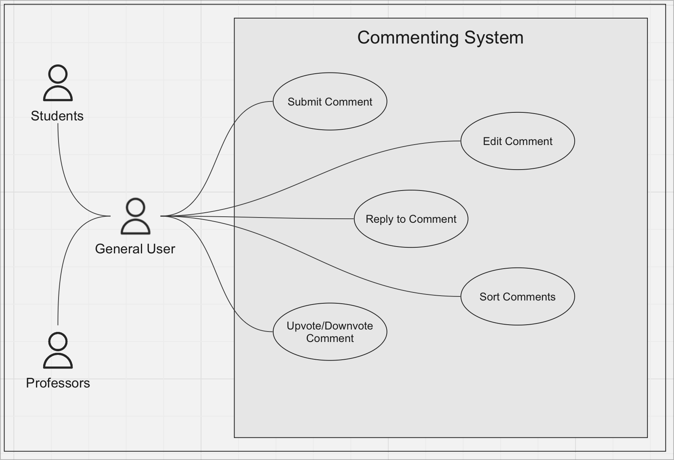

[Link to Miro Board](https://miro.com/app/board/uXjVNZ96xM0=/)

**Use Case Descriptions**

**Submit Comment**

* **Name/Title:** Submit Comment
* **ID:** 2137009
* **Description:** Users can post a comment on a feedback to share additional insights, agree or disagree with the original feedback, or simply partake in the discussion. Posting a comment fosters an environment of open communication and interaction.
* **Precondition:** User is logged in and is viewing a feedback.
* **Success Postcondition:** Comment is added below the feedback or under the specific thread.

**Edit Comment**

* **Name/Title:** Edit Comment
* **ID:** 2137010
* **Description:** Users can modify their previously posted comments to correct, clarify, or update their statements. This ensures that the discourse remains accurate and relevant over time.
* **Precondition:** User is logged in and wants to make changes to their own comment.
* **Success Postcondition:** The selected comment is updated with the new text.

**Reply to Comment**

* **Name/Title:** Reply to Comment
* **ID:** 2137011
* **Description:** Users can post a direct response to an existing comment. This nested commenting structure promotes organized and threaded conversations, mirroring real-life dialogues.
* **Precondition:** User is logged in and wants to respond to a specific comment.
* **Success Postcondition:** The response is positioned directly under the targeted comment.

**Sort Comments**

* **Name/Title:** Sort Comments
* **ID:** 2137012
* **Description:** Users can rearrange comments based on criteria like newest, oldest, or most upvoted to tailor their reading experience. Sorting makes it easy for users to locate comments of interest or gauge community sentiments.
* **Precondition:** User is logged in and is viewing a thread of comments.
* **Success Postcondition:** Comments are sorted based on user preference.

**Upvote/Downvote Comment**

* **Name/Title:** Upvote/Downvote Comment
* **ID:** 2137013
* **Description:** Users can express approval or disapproval on a comment. This voting mechanism acts as a tool for the community to self-moderate and highlight valuable contributions, helping to elevate the quality of the discussion.
* **Precondition:** User is logged in and wants to rate a specific comment.
* **Success Postcondition:** The comment’s vote count reflects the user’s choice, either increasing or decreasing by one.